Simple multiplication
DESCRIPTION:
This kata is about multiplying a given number by eight if it is an even number and by nine otherwise.

SOLUTION:
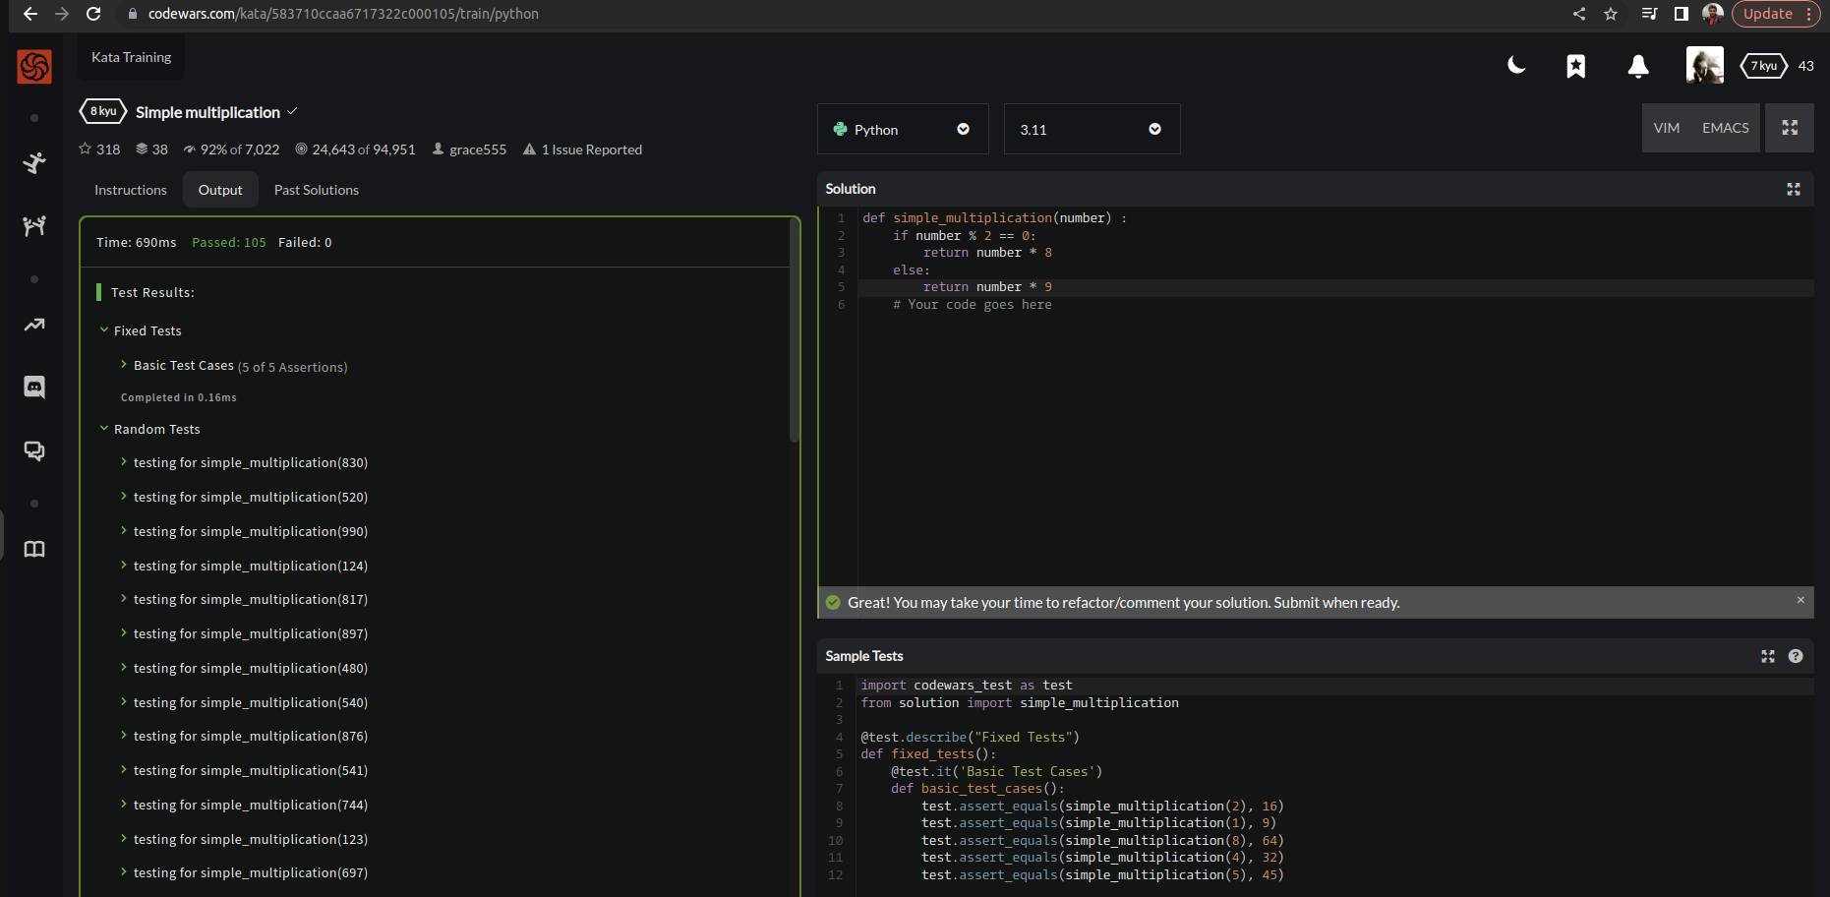

EXPLANATION:
So we’re asked to make some calculations based on the given conditions or input. Therefore, we’ll declare our parameter value in if condition with mod 2 which is mainly an even logic, this logic will return the value multiplied by 8. Moreover in else condition number will be returned by multiplied with 9 as odd number logic.

